Business Question and Visualization Report
Date | 19 September 2026
Team ID | MCA
Project Name | Smartphone Usage, Digital Addiction & Well-Being Analytics
Maximum Marks | 5 Marks

Visualization development refers to the process of converting raw data into graphical representations that support understanding, analysis, comparison, and decision-making. In this project, Power BI was used to analyze smartphone usage, screen time, sleep, gaming, social-media activity, notifications, stress, academic/work impact, and addiction levels. The dashboard combines KPI cards, bar charts, donut charts, scatter-style visuals, line charts, filters, and analytical visuals to make patterns in digital behaviour easier to interpret.
Business Questions and Visualisation
The following business questions were derived from the available Power BI dashboards. Each question identifies the relevant visualization and explains what the visual is intended to communicate. The screenshots are included as evidence of the implemented Power BI visuals.
Dashboard Summary
Metric | Value | Interpretation
Total users analyzed | 7,500 | Overall dataset size represented in the dashboard.
Addicted users | 5,308 | Count shown for users classified as addicted.
Average age | 26.57 | Average age of the analyzed users.
Average daily screen time | 7.50 hours | Average daily screen exposure represented in the KPI page.
Average social-media time | 3.27 hours | Average time spent on social media.
Average gaming time | 2.01 hours | Average gaming time.
Average sleep | 6.74 hours | Average sleep duration.
Average notifications/day | 134.26 | Average daily notifications received.
Average app opens/day | 97.83 | Average number of application opens per day.
Average weekend screen time | 9.24 hours | Weekend screen exposure is higher than the daily KPI shown on the dashboard.

1. Business Question and Visualisation
Business Question: What is the overall scale of smartphone usage and digital activity in the dataset?
Visualization: KPI cards provide a high-level view of the 7,500 users, 5,308 addicted users, average age, screen time, social-media hours, gaming hours, sleep hours, notifications, app opens, weekend screen time, and work/study hours.
Screenshot of visualisation
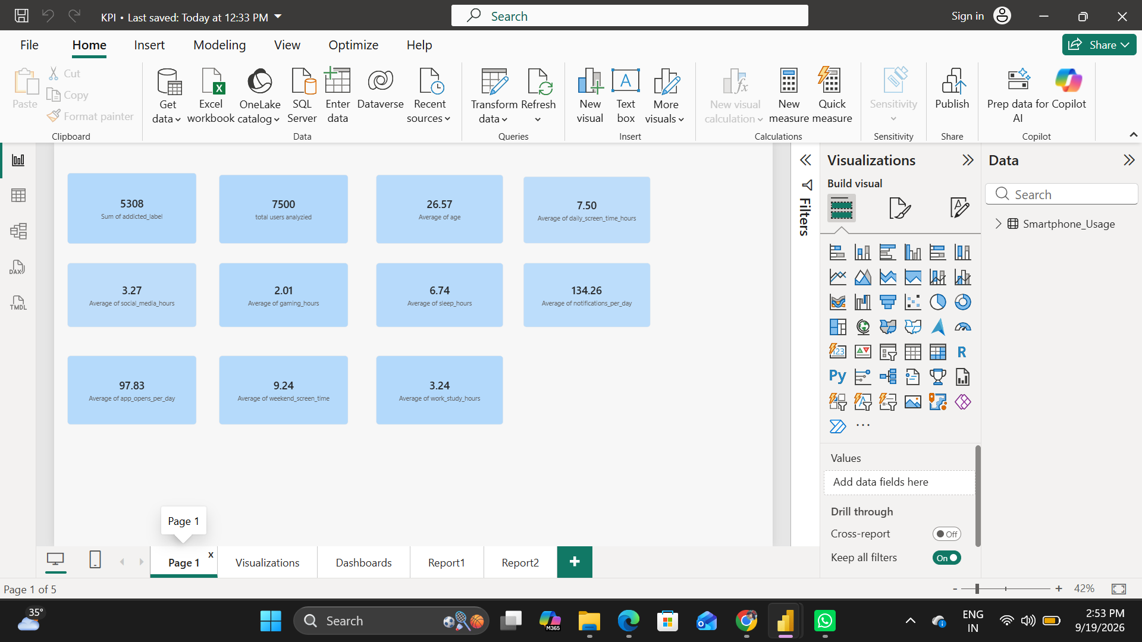
Screenshot of the KPI summary page
Interpretation: This visualization is intended to support comparison and pattern identification within the smartphone-usage dataset. The values shown should be interpreted together with the available filters and category definitions in the Power BI report.

2. Business Question and Visualisation
Business Question: How does average daily screen time vary by gender?
Visualization: A column/bar visualization compares average daily screen-time hours across Male, Female, and Other categories. The bars are close in height, indicating broadly similar average screen-time levels across the displayed gender groups.
Screenshot of visualisation
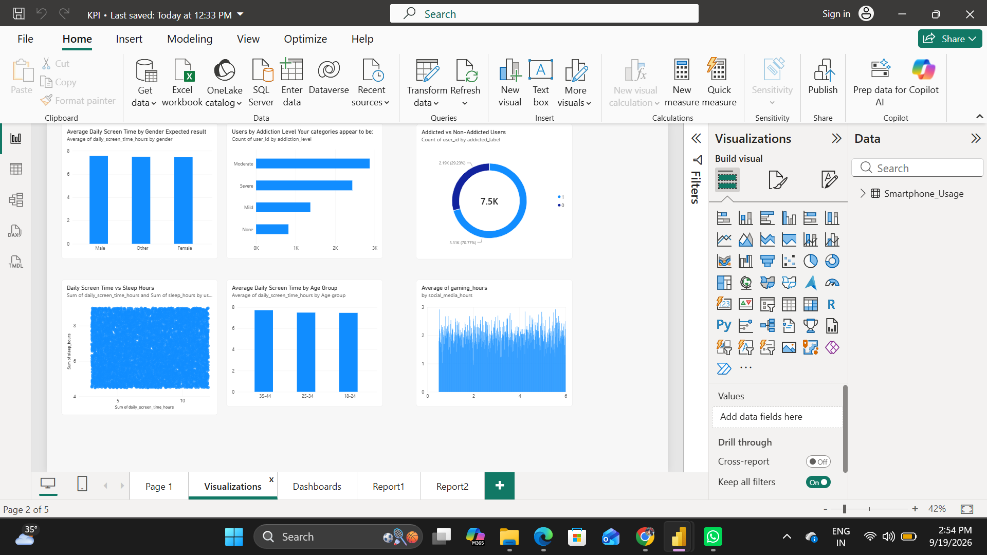
Screenshot showing average daily screen time by gender
Interpretation: This visualization is intended to support comparison and pattern identification within the smartphone-usage dataset. The values shown should be interpreted together with the available filters and category definitions in the Power BI report.

3. Business Question and Visualisation
Business Question: How are users distributed across addiction levels?
Visualization: The addiction-level visualization compares the number of users in Mild, Moderate, Severe, and None categories. It helps identify which addiction classifications contain the largest user populations.
Screenshot of visualisation
Screenshot showing users by addiction level
Interpretation: This visualization is intended to support comparison and pattern identification within the smartphone-usage dataset. The values shown should be interpreted together with the available filters and category definitions in the Power BI report.

4. Business Question and Visualisation
Business Question: What is the proportion of addicted versus non-addicted users?
Visualization: A donut chart presents the split between addicted and non-addicted users. The dashboard shows approximately 5.31K users in one category and 2.19K in the other, giving a direct view of the classification balance.
Screenshot of visualisation
Screenshot showing addicted versus non-addicted users
Interpretation: This visualization is intended to support comparison and pattern identification within the smartphone-usage dataset. The values shown should be interpreted together with the available filters and category definitions in the Power BI report.

5. Business Question and Visualisation
Business Question: Is daily screen time related to sleep hours?
Visualization: The scatter-style visualization places daily screen time against sleep hours. It is designed to examine whether changes in screen exposure correspond to differences in reported sleep duration.
Screenshot of visualisation
Screenshot showing daily screen time versus sleep hours
Interpretation: This visualization is intended to support comparison and pattern identification within the smartphone-usage dataset. The values shown should be interpreted together with the available filters and category definitions in the Power BI report.

6. Business Question and Visualisation
Business Question: How does average screen time differ across age groups?
Visualization: The age-group chart compares average daily screen-time hours for the 18–24, 25–34, and 35–44 groups. The displayed values are close, allowing comparison of screen-time behaviour across age segments.
Screenshot of visualisation
Screenshot showing average screen time by age group
Interpretation: This visualization is intended to support comparison and pattern identification within the smartphone-usage dataset. The values shown should be interpreted together with the available filters and category definitions in the Power BI report.

7. Business Question and Visualisation
Business Question: How does gaming time vary across users?
Visualization: The gaming-hours visual shows the distribution of gaming time across the analyzed records. This helps identify the typical range of gaming activity and its contribution to overall digital usage.
Screenshot of visualisation
Screenshot showing gaming-hours behaviour
Interpretation: This visualization is intended to support comparison and pattern identification within the smartphone-usage dataset. The values shown should be interpreted together with the available filters and category definitions in the Power BI report.

8. Business Question and Visualisation
Business Question: How does weekend screen time vary between addicted and non-addicted users?
Visualization: The dashboard compares average weekend screen time by addiction status. The addicted category is shown at a higher average than the not-addicted category, making the visual useful for comparing weekend digital behaviour.
Screenshot of visualisation
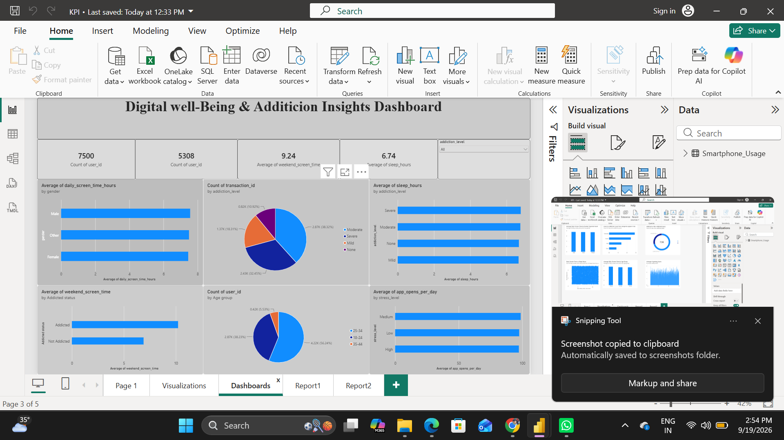
Screenshot showing weekend screen time by addiction status
Interpretation: This visualization is intended to support comparison and pattern identification within the smartphone-usage dataset. The values shown should be interpreted together with the available filters and category definitions in the Power BI report.

9. Business Question and Visualisation
Business Question: How does work/study time differ by academic/work impact?
Visualization: The report compares average work/study hours for users grouped by academic/work impact. The visualization supports analysis of how smartphone-related behaviour is associated with reported study or work impact categories.
Screenshot of visualisation
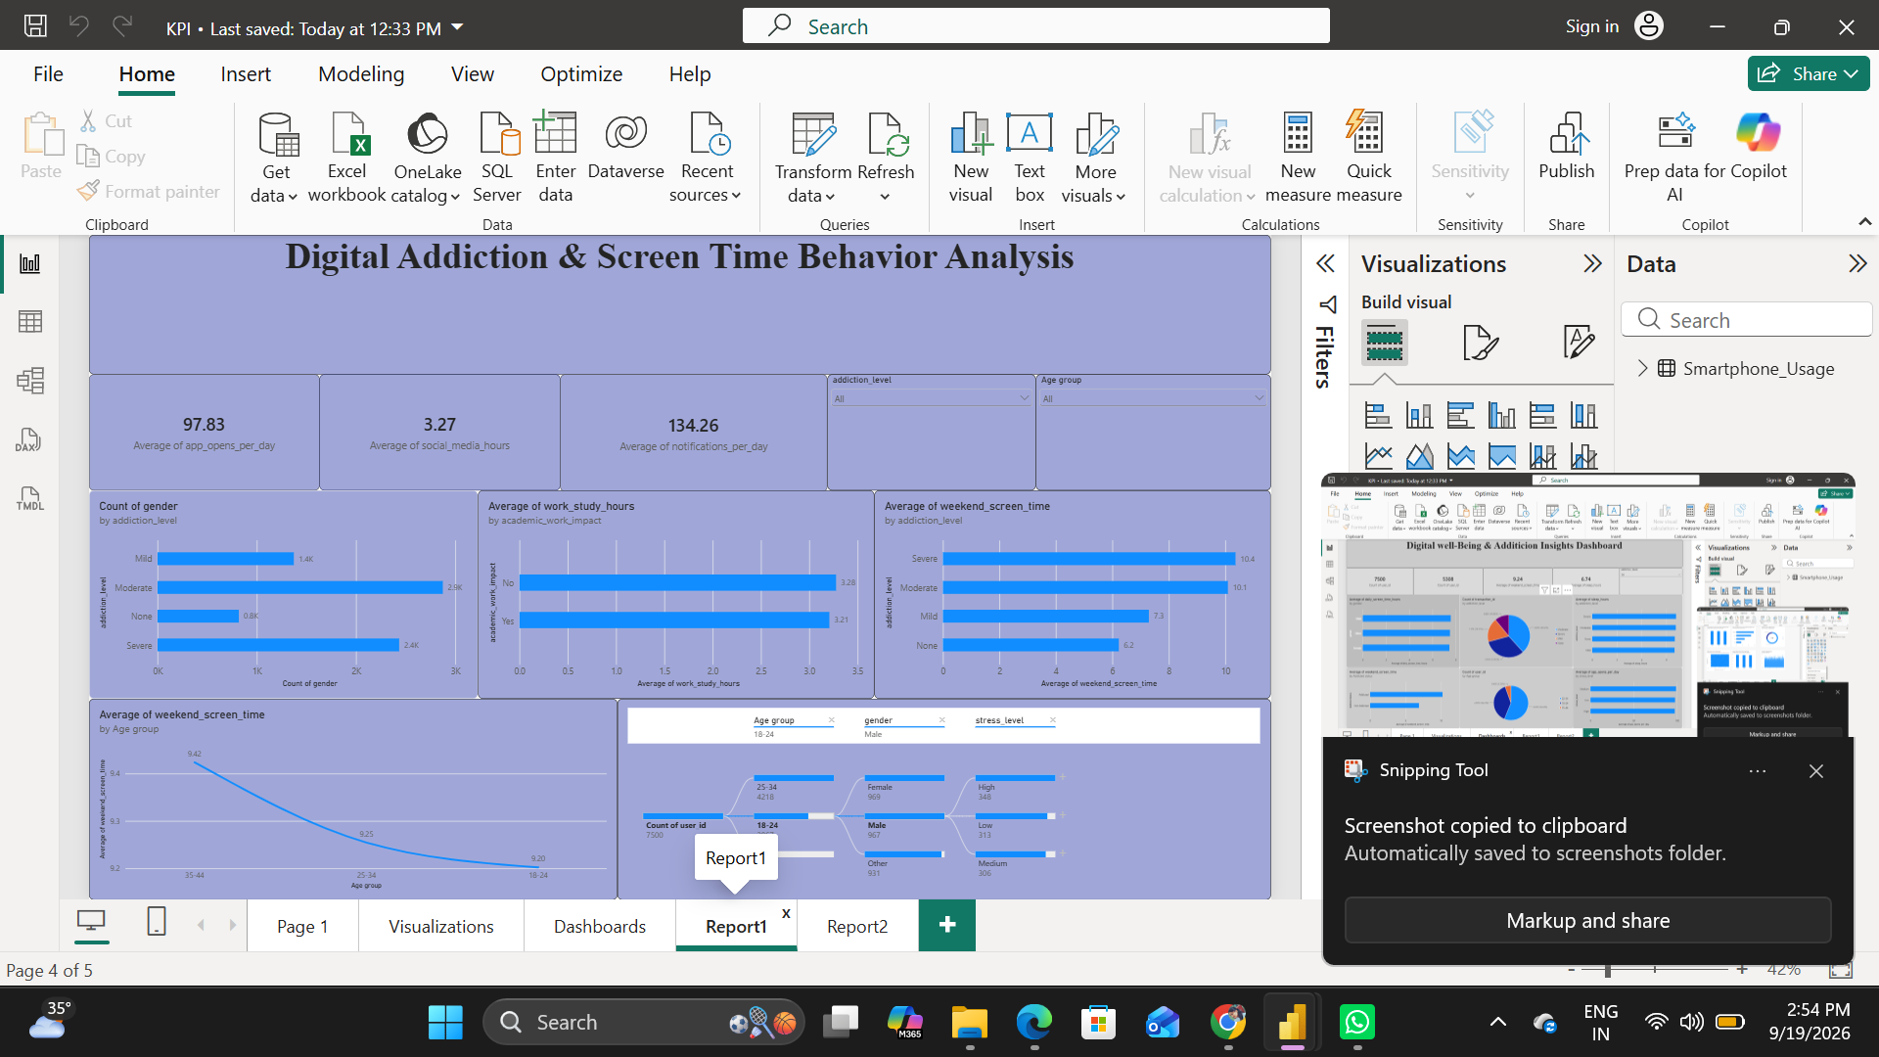
Screenshot showing work/study hours by academic/work impact
Interpretation: This visualization is intended to support comparison and pattern identification within the smartphone-usage dataset. The values shown should be interpreted together with the available filters and category definitions in the Power BI report.

10. Business Question and Visualisation
Business Question: How does social-media usage vary across addiction levels?
Visualization: A bar chart compares average social-media hours across None, Mild, Moderate, and Severe addiction levels. This visual highlights differences in social-media exposure among the addiction categories.
Screenshot of visualisation
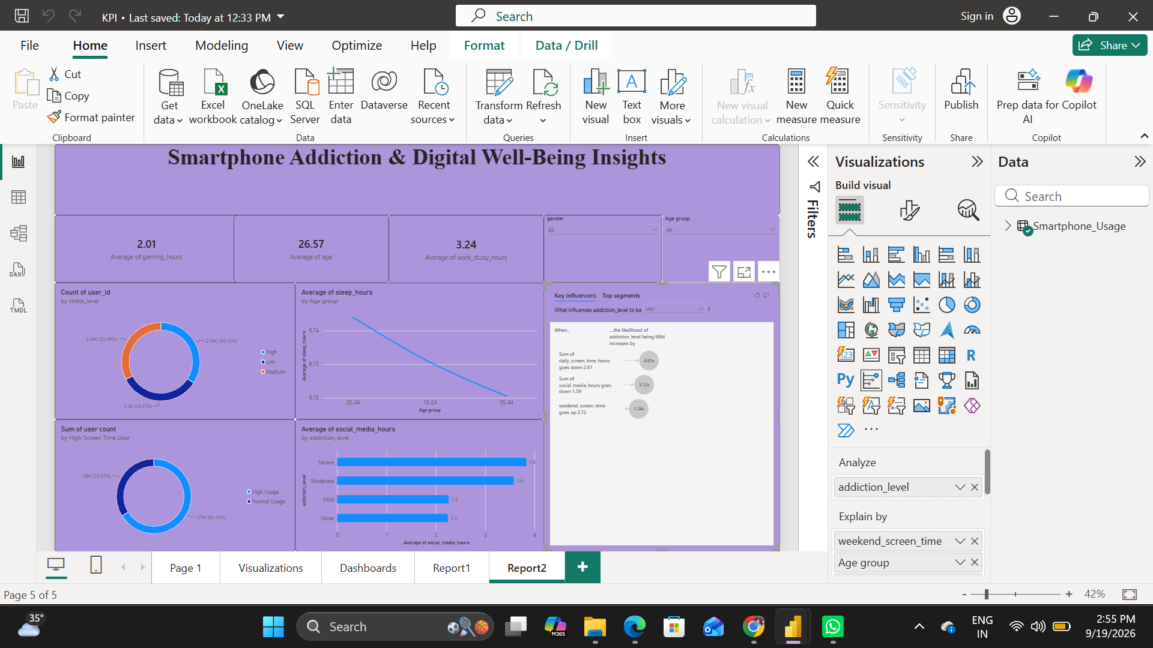
Screenshot showing social-media hours by addiction level
Interpretation: This visualization is intended to support comparison and pattern identification within the smartphone-usage dataset. The values shown should be interpreted together with the available filters and category definitions in the Power BI report.

11. Business Question and Visualisation
Business Question: Which factors are highlighted as influential for addiction level?
Visualization: The Key Influencers visual is used to identify variables associated with changes in the selected addiction-level category. In the displayed analysis, daily screen time, social-media hours, and weekend screen time appear as important explanatory factors for the selected segment.
Screenshot of visualisation
Screenshot showing Key Influencers analysis
Interpretation: This visualization is intended to support comparison and pattern identification within the smartphone-usage dataset. The values shown should be interpreted together with the available filters and category definitions in the Power BI report.

12. Business Question and Visualisation
Business Question: How does sleep duration vary across age groups?
Visualization: The line visualization compares average sleep hours by age group. It provides a compact view of differences in sleep duration across the 18–24, 25–34, and 35–44 groups.
Screenshot of visualisation
Screenshot showing average sleep hours by age group
Interpretation: This visualization is intended to support comparison and pattern identification within the smartphone-usage dataset. The values shown should be interpreted together with the available filters and category definitions in the Power BI report.
Conclusion
The Power BI report provides a multi-page view of smartphone usage and digital well-being. The dashboard combines summary KPIs with demographic, addiction, screen-time, sleep, gaming, social-media, stress, and work/study analyses. Together, the visualizations provide a structured basis for understanding patterns in the dataset and for communicating findings through interactive business questions and visual evidence.

